**SQL PROJECT**

1. Create a database named employee, then import data_science_team.csv proj_table.csv and emp_record_table.csv into the employee database from the given resources.

**CODE:** create database employee;

**OUTPUT:**

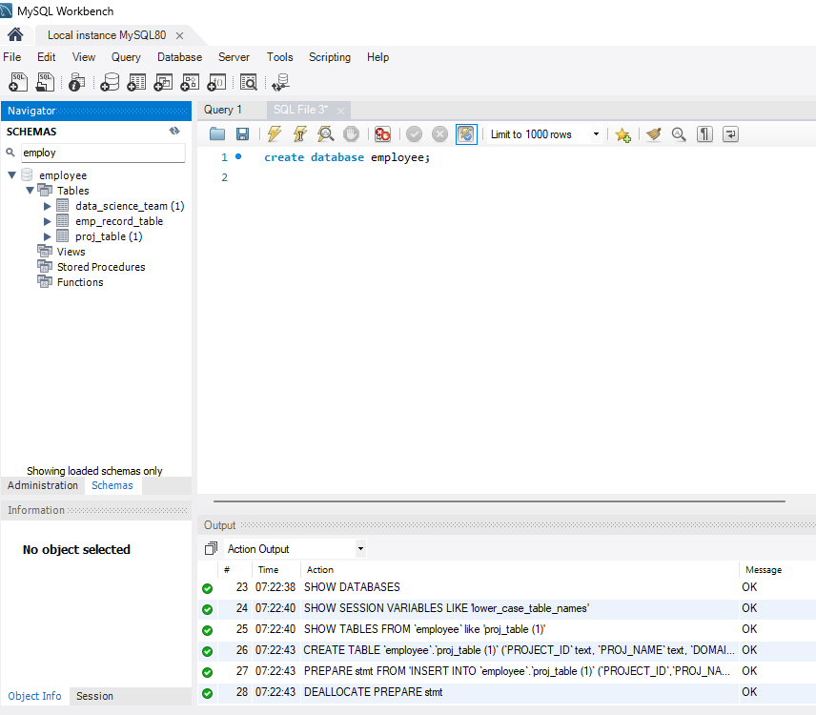

1. Write a query to fetch EMP_ID, FIRST_NAME, LAST_NAME, GENDER, and DEPARTMENT from the employee record table, and make a list of employees and details of their department.

**CODE:** select emp_id,first_name,last_name,gender,dept from emp_record_table order by dept;

**OUTPUT**:

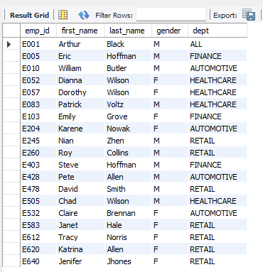

**3**. Write a query to fetch EMP_ID, FIRST_NAME, LAST_NAME, GENDER, DEPARTMENT, and EMP_RATING if the EMP_RATING is: • less than two • greater than four • between two and four

**CODE**: select emp_id,first_name,last_name,gender,dept,emp_rating from emp_record_table where emp_rating<2;

**OUTPUT**:

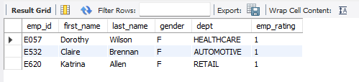

select emp_id,first_name,last_name,gender,dept,emp_rating from emp_record_table where emp_rating>4;

**OUTPUT**:

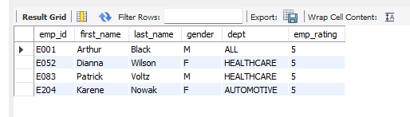

select emp_id,first_name,last_name,gender,dept,emp_rating from emp_record_table where emp_rating between 2 and 4;

**OUTPUT**:

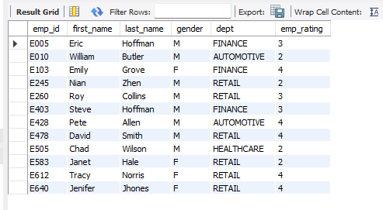

**4**.Write a query to concatenate the FIRST_NAME and the LAST_NAME of employees in the Finance department from the employee table and then give the resultant column alias as NAME.

**CODE**:

select emp_id,first_name,last_name,gender,dept, concat(first_name, last_name) as NAME from emp_record_table where dept='finance';

**OUTPUT**:

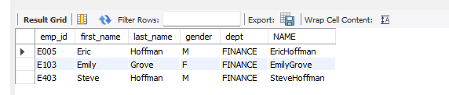

**5**. Write a query to list down all the employees from the healthcare and finance departments using union. Take data from the employee record table.

**CODE**: select * from emp_record_table where dept='finance'

union

select * from emp_record_table where dept='healthcare' ;

**OUTPUT**:

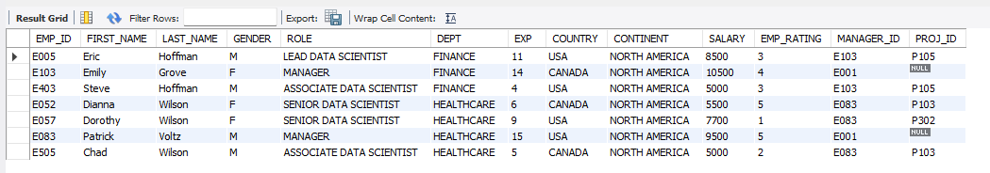

**6**. Write a query to list down employee details such as EMP_ID, FIRST_NAME, LAST_NAME, ROLE, DEPARTMENT, and EMP_RATING grouped by dept. Also include the respective employee rating along with the max emp rating for the department.

**CODE**: select emp_id,first_name,last_name,role,dept,emp_rating, max(emp_rating) over(partition by dept) as max_rating from emp_record_table;

**OUTPUT**:

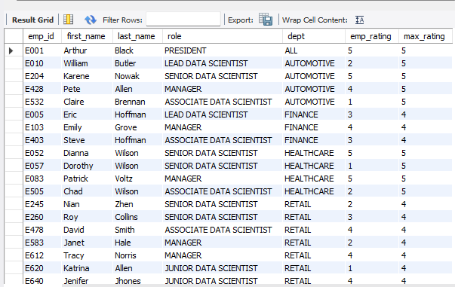

**7**. Write a query to calculate the minimum and the maximum salary of the employees in each role. Take data from the employee record table.

**CODE**: select role, max(salary) as max_sal_role, min(salary) as min_sal_role from emp_record_table group by role ;

**OUTPUT**:

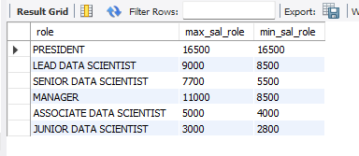

**8**. Write a query to assign ranks to each employee based on their experience. Take data from the employee record table.

**CODE**: select emp_id, exp, rank() over( order by exp) as exp_rank from emp_record_table ;

**OUTPUT**:

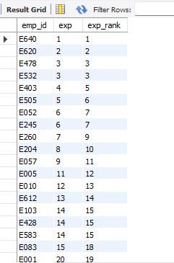

**9**. Write a query to create a view that displays employees in various countries whose salary is more than six thousand. Take data from the employee record table.

**CODE**: create view emp_view as

select emp_id , salary , country from emp_record_table where salary >6000 ;

select * from emp_view;

**OUTPUT**:

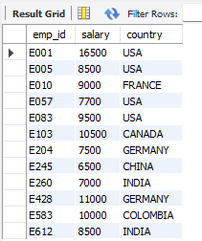

**10**. Write a nested query to find employees with experience of more than ten years. Take data from the employee record table.

**CODE**: select emp_id , exp from (

select * from emp_record_table where exp >10 order by exp)

as exp_greater;

**OUTPUT**:

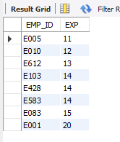

**11**. Write a query to create a stored procedure to retrieve the details of the employees whose experience is more than three years. Take data from the employee record table.

**CODE**: create procedure emp_details()

select * from emp_record_table where exp > 3 ;

call emp_details();

**OUTPUT**:

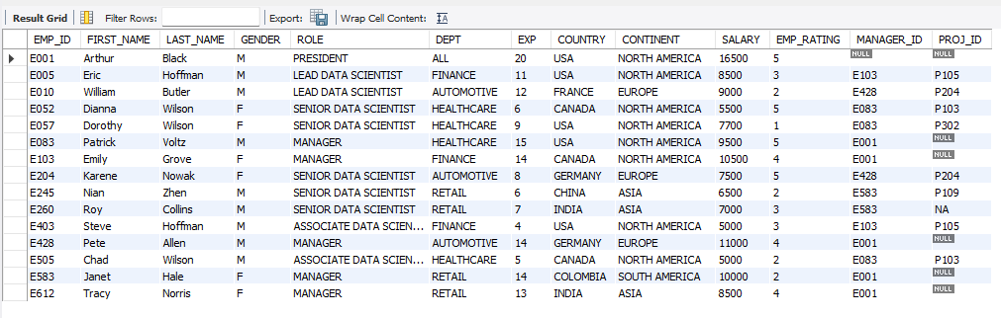

**12**. Write a query to calculate the bonus for all the employees, based on their ratings and salaries (Use the formula: 5% of salary * employee rating).

**CODE**:select emp_id, salary, emp_rating, (salary*0.05) * emp_rating as bonus from emp_record_table;

**OUTPUT**:

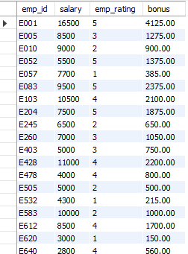

**13**. Write a query to calculate the average salary distribution based on the continent and country. Take data from the employee record table.

**CODE**: select country , continent , avg(salary) from emp_record_table group by continent , country;

**OUTPUT**:

